Titanic survival prediction model
Group 1: Jessica Owens, Vijay Sharma, and Skylar Peven

Introduction
On April 15, 1912, during her maiden voyage, the widely considered “unsinkable” RMS Titanic sank after colliding with an iceberg in the Atlantic Ocean. Unfortunately, there weren’t enough lifeboats for everyone onboard, resulting in the death of 1502 out of 2224 passengers and crew (Cukierski, 2012). Maritime rule tells us that evacuation priority was given to women and children but varying interpretations and social class hierarchies also played a major role in deciding who made it to safety. Our project aims to build and evaluate a machine learning model to predict which passengers on the Titanic survived the disaster.

Data Selection

The analysis used the well-known Titanic dataset, which includes 12 variables and 1308 rows in the dataset. Following are the dataset attributes -
- Passenger ID
- survival
  - binary
    - 0=No
    - 1=Yes
- pclass
  - Ticket class
    - 1=1st
    - 2=2nd
    - 3=3rd
- name
- sex
- age
- sibsp - (number of siblings + spouses aboard the Titanic) - Calculated Col
- parch - (number of parents + children aboard the Titanic) - Calculated Col
- ticket (number)
- fare
- cabin (number)
- embarked
  - Port of Embarkation:
    - C=Cherbourg
    - Q=Queenstown
    - S=Southampton

The dataset was provided pre-split into training and test datasets for model creation and testing on unseen data however, for our analysis we chose to use only the test datasets and split into test and training.

Data Preparation

The data preparation process involved several key steps, starting from initial loading and inspection through cleaning and feature engineering.

Initial Inspection and Missing Values
The analysis used the well-known Titanic dataset. The initial training dataset, after being loaded, had 891 rows and 12 columns. A check for missing values revealed three columns with missing data:
- Age: 177 missing values.
- Cabin: 687 missing values.
- Embarked: 2 missing values.

Data Cleaning and Feature Engineering
Columns with low predictive value or too many missing values were dropped. We used a correlation matrix to identify the features with a low predictive value. These included 'Cabin' (over 70% missing values), 'PassengerId', 'Name' and 'Ticket'. The two rows with missing 'Embarked' values were also dropped.

A 'ChildFlag' was created, set to 1 if the passenger's Age was <18 OR if their Parch (parents/children aboard) was >0, and 0 otherwise. Missing 'Age' values were imputed by calculating the mean age grouped by the 'ChildFlag' and applying these group averages to the NaNs. 'FamilySize' was computed as SibSp + Parch + 1. 'FamilyCategory' was created by binning 'FamilySize' into 'Single' (1 person), 'Small Family' (2-4 members), and 'Large Family' (5-11 members). The categorical variables 'Sex', 'Embarked', 'Pclass', and 'FamilyCategory' were converted to numeric format using one-hot encoding. One Hot Encoding is a method for converting categorical variables into a binary format. It creates new columns for each category where 1 means the category is present and 0 means it is not. The primary purpose of One Hot Encoding is to ensure that categorical data can be effectively used in machine learning models. (One Hot Encoding in Machine Learning, 2025)

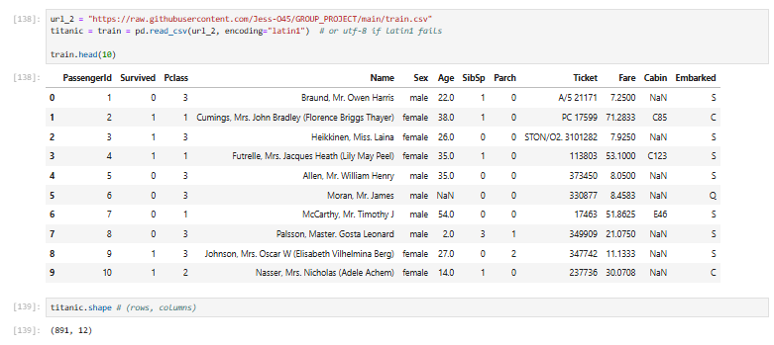
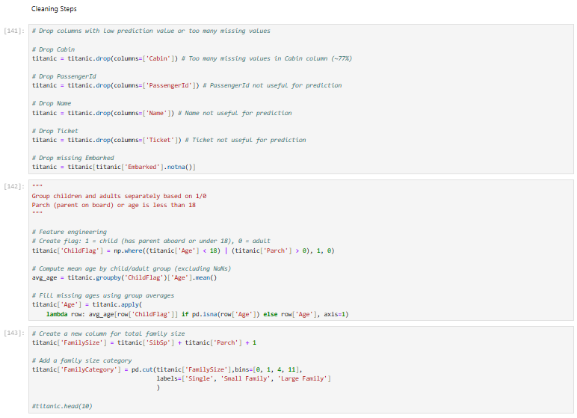

Modeling & Methods
Multiple models were evaluated to determine the most effective one for this classification task. These will run the gamut from simple logistic regression to more complex, potentially higher-performing models.
Logistic Regression: A good baseline model for binary classification problems. It provides a simple, interpretable model to understand feature importance, such as the strong correlation between gender and survival. (Understanding Logistic Regression in Python, 2024)
Random Forest: An ensemble method that uses multiple decision trees to improve predictive accuracy and control for overfitting. This model is robust and often performs well on datasets with mixed data types, like Titanic data.
Gradient Boosting (e.g., XGBoost): Another powerful ensemble technique that builds models sequentially, with each new model correcting the errors of the previous ones. This can lead to very high accuracy but can be more complex to interpret than Random Forest.
K-Nearest Neighbors (KNN): A non-parametric model that classifies a data point based on the classification of its neighbors. This offers an alternative approach to tree-based ensemble methods.
Performance Metrics: “Data science is a field that involves working with large amounts of data to derive insights and make informed decisions. To measure the effectiveness of data models and algorithms, it is necessary to use performance metrics. Performance metrics provide a quantitative measure of how well a model is performing and can help data scientists determine if their models are effective or need improvement.” (Performance Metrics in Data Science: A Comprehensive Guide, 2023)
For each model, we calculated the following metrics on the test set:
Accuracy: The percentage of passengers correctly predicted to survive or perish. This is a key metric for the Kaggle competition associated with this dataset. However, this metric can be deceiving as the dataset is imbalanced.
Confusion Matrix: A table summarizing the model’s performance. It is broken down into four categories.
- True Positives (TP): Correctly predicting a survivor.
- True Negatives (TN): Correctly predicting a non-survivor.
- False Positives (FP): Incorrectly predicting a non-survivor as a survivor.
- False Negatives (FN): Incorrectly predicting a survivor as a non-survivor.
Precision and Recall: Precision measures the accuracy of the positive predictions (of survivors), while recall measures the model's ability to find all the positive samples.
F1-Score: A happy medium between precision and recall, useful for uneven class distribution, such as the case with this project.
Risks, Ethical Implications and Mitigation Strategies
Risk of bias: The historical data reflects the biases of the time, such as social class and gender roles, which directly influenced survival rates. The model will likely learn and reflect these historical biases.
- Mitigation: Acknowledge and document the inherent biases in the dataset and ensure the project's findings are interpreted in their historical context rather than taken as a prescriptive model for modern situations.
Risk of misrepresentation: The model's predictions are statistical probabilities, not certainties. Oversimplifying the results could minimize the human tragedy behind the data.
- Mitigation: Clearly communicate the limitations and uncertainty of the model's predictions. The project's purpose is to analyze historical data, not to pass judgment on individuals.
Ethical use of data: Reusing historical data analysis can be sensitive, particularly when it concerns a tragic event.
- Mitigation: We can be mindful of the context and avoid sensationalizing the results. The focus will be on respectful analysis and learning rather than exploiting the historical context for compelling results.
Result Interpretation
We begin our interpretation with a review of the correlation coefficients. Being male ('Sex' with a value of 1, after one-hot encoding) had the largest negative coefficient (approx. -2.5). This indicates that being male was the strongest factor negatively correlated with survival. ‘ChildFlag’ had the largest positive coefficient (approx. 0.5), suggesting that passengers categorized as children were more likely to survive. Traveling in 3rd class had a large negative coefficient (approx. -1.7), indicating a strong negative correlation with survival. The family size feature we’ve created showed us that a smaller family of 2-4 had a positive coefficient (approx. 0.40) and the large family of 5-11 with a negative coefficient (approx. -1.75). This indicates that larger families are less likely to survive than small families.

Building Models and Evaluating XGBoost
Four models were built and evaluated after splitting the data into an 80% training set and a 20% test set. Logistic Regression, Random Forest, XGBoost, and K-Nearest Neighbors (KNN).
Model Accuracy
- Logistic Regression 0.7697
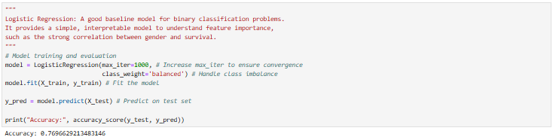
- Random Forest 0.7865
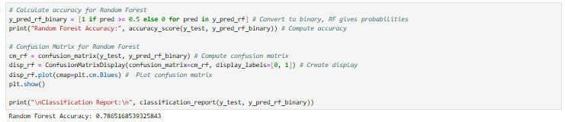
- XGBoost 0.8090
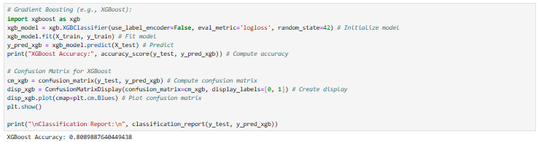
- K-Nearest Neighbors (KNN) 0.7135
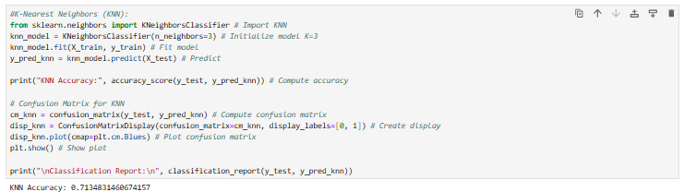
The XGBoost model was the most effective classifier model. The analysis suggests that survival on the Titanic was heavily influenced by a few key features, as highlighted by the Logistic Regression coefficients.
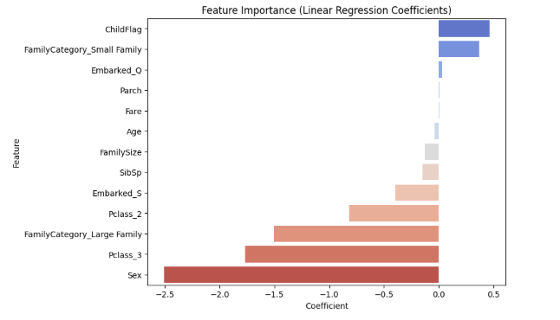

Conclusion
Our goal was to predict which passengers on the Titanic would survive the disaster based on information known about them at the time. This is a very popular machine learning problem and can teach us about predicting survival in theoretical scenarios and preventing future loss of life in a similar situation.
The XGBoost model is clearly the best performing model with 81% accuracy. The feature importance results align with the “women and children first” historical narrative, as sex and the ‘ChildFlag’ were the most significant predictors of survival. We also found that the smaller the family size the higher the likely hood of surviving was. This also makes sense as smaller families were able to get to lifeboats faster. Class was also very important in predicting survival as the higher end ticket holders were significantly more likely to survive.
The next steps would be to perform hyperparameter tuning on the XGBoost model and using techniques like GridsearchCV to try and achieve even better performance, as this model has demonstrated the best predictive capability thus far.

References
Cukierski, W. (2012). Titanic - Machine Learning from Disaster. Retrieved from Kaggle: https://www.kaggle.com/competitions/titanic/overview
One Hot Encoding in Machine Learning. (2025, Jully 07). Retrieved from Geeks for Geeks: https://www.geeksforgeeks.org/machine-learning/ml-one-hot-encoding/
Performance Metrics in Data Science: A Comprehensive Guide. (2023, April 9). Retrieved from Medium: https://medium.com/@data-overload/performance-metrics-in-data-science-a-comprehensive-guide-7b036e0e18e4
Understanding Logistic Regression in Python. (2024, August 11). Retrieved from Data Camp: https://www.datacamp.com/tutorial/understanding-logistic-regression-python

